Year 1 Newsletter
Autumn Term 1
Welcome back I hope you had a fantastic summer. We've got an exciting year ahead of us!
A little about me…
Hello! My name is Miss Williams, I am so excited to be your child’s teacher this year, this will be my 3rd year of teaching and I’m loving every second of it! I have been a part of the Rodmersham School community for many of years starting as a 1:1 assistant, then a teaching assistant to now a teacher. I’m very excited about being in year 1 as it’s something brand new – but I promise it is going to be an awesome year!
Our plans for this term…
To start off the term we will do a lot about getting to know each other and setting those expectations for year 1.
This term we have got lots of exciting things ahead, we are going to be looking at animals including humans in science, online safety and technology in computing, in history we will be looking at what was our grandparents’ history was like and lastly my favourite topic, art, we will be looking at lines and shapes.

Literacy
In Literacy we will be focusing on writing descriptive sentences using the book, The Bog Baby. We will also be focusing on what makes great sentences, such as, using capital letters, finger spaces, letter formation and full stops.

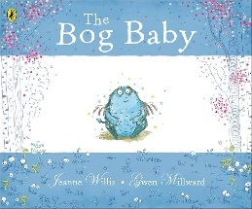

Phonics
In Phonics, we will still be using the Monster Phonics program which the children are very familiar with. We will be doing a lot of retrieval based on all the sounds they learnt in year R, this will either be through the scheme or during provision.

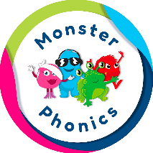
For the first term we will look at new graphemes, practice blending for reading, practice segmenting for spellings and using all their knowledge to write sentences.

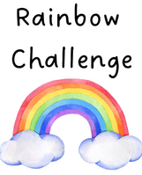

A highlight of our week is the Rainbow Challenge - children are encouraged to complete five optional activities throughout the week, each linked to a different area of learning and represented by a colour. For every challenge completed, they earn a coloured lolly stick. Once they've collected all five, they get to colour in a rainbow on their bookmark. When all the rainbows on their bookmark are complete, they receive a prize to celebrate their effort and resilience. It’s a fun and motivating way to encourage independence, exploration, and a love of learning!

Reading
In their yellow reading record books will be a little information piece about ‘expectations for reading’, this just outlines everything. We will complete reading checks on Monday and give out new Monster Phonics books. We are asking for book folders to be in school every day. As a school we ask that reading at home is done at least 3 times a week and a family member signs their reading record book. (A helpful guide for what to write in the yellow book will be going home)
Additionally, I will be doing phonics screenings with the children to see what sounds they can remember from year R. Once these are complete we will send home phonics books, you may find a book you have already read may go home, this is just to secure their sound knowledge.

Continuous Provision & Rainbow Challenges
In year 1, we offer a rich and engaging continuous provision environment that supports all areas of learning. Our classroom is set up with different areas, including writing, phonics, maths, creative, topic-based zones, a cosy reading corner, and even carpet-based activities. These areas are updated regularly to keep the children inspired and challenged.
Maths
In maths we will still be using Master the Curriculum, for the first term we will do a lot of retrieval on what they learnt in year R, this will either be through the scheme or during provision. We will begin looking at place value within 10 and then we will move onto addition and subtraction within 10.

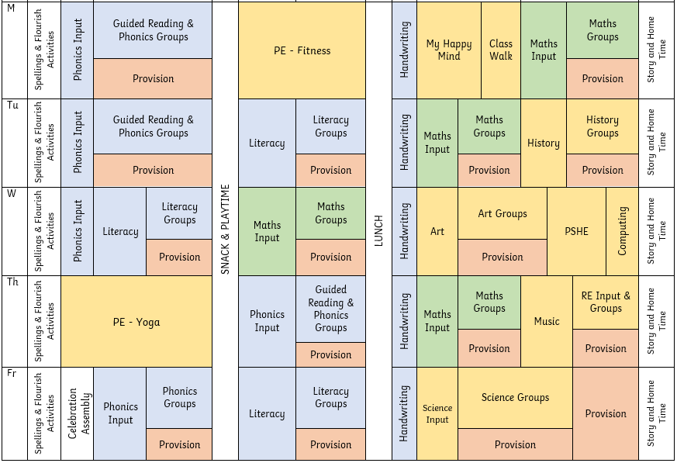
Things I need to remember…
- PE days – Monday & Thursday
- To bring my book folder in everyday

Things I need to do…
- Bring my wellie boots back into school – ready for the bad weather!
- Bring in an old t-shirt for painting, so we can wear them over our school shirts to protect them. (We will keep hold of these for the whole year, so please bring a shirt they don’t mind ruining)
- Please make sure all of your child’s belongings are clearly labelled with their name.

Thank you for taking the time to read this (rather long) newsletter. I hope it helps put your mind at ease about what your children are up to in Year 1. I’m really looking forward to the year ahead and building strong relationships with both the children and you. If you have any questions or concerns, please don’t hesitate to message me on Class Dojo!
Timetable
Below I have attached a rough outline of what we will be doing each day – it looks very confusing with all the colours, I know!
Blue is for writing, reading or phonics. Green is for maths. Yellow is for topic-based lessons and then lastly, red is for provision.

