Year 1 Newsletter
Autumn Term 2
Welcome back I hope you had a great week off. We've got an exciting term ahead of us leading up to Christmas!
Our plans for this term…
This term we have got lots of exciting things ahead, we are going to be looking at animals including humans in science, technology around us and introducing the children to Purple Mash in computing, in geography we are looking at maps and the UK, and lastly, in RE we are considering different religions and festivals.

Literacy
In Literacy we will be focusing on writing a recount using the book, Meerkat Mail. We will also be focusing on what makes great sentences, such as, using capital letters, finger spaces, letter formation and full stops.

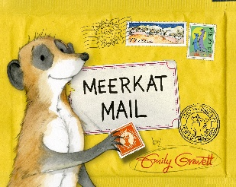

Phonics
In Phonics, we will still retrieve previous graphemes from year R, we will continue looking at new graphemes, using them in our daily writing, practicing segmenting for spellings and using all their knowledge to write more detailed sentences.

Maths
In maths we will still be doing a lot of retrieval on what they learnt in year R, this will either be through the scheme or during provision. This term we will be looking at addition and subtraction within 10. We will be understanding part whole models, number bonds to 10, adding numbers together, subtracting numbers and writing number sentences.

Reading
We will continue to complete reading checks on Monday and give out new Monster Phonics books. We are asking for book folders to be in school every day. As a school we ask that reading at home is done at least 3 times a week and a family member signs their reading record book.

Continuous Provision & Rainbow Challenges
In year 1, we continue to offer a rich and engaging continuous provision environment that supports all areas of learning. A highlight of our week is the Rainbow Challenge - children are encouraged to complete five activities throughout the week, each linked to a different area of learning and represented by a colour. Once they've collected all five, they receive a prize to celebrate their effort and resilience. It’s a fun and motivating way to encourage independence, exploration, and a love of learning!

Timetable
Below I have attached a rough outline of what we will be doing each day – it looks very confusing with all the colours, I know!
Blue is for writing, reading or phonics. Green is for maths. Yellow is for topic-based lessons and then lastly, red is for provision.

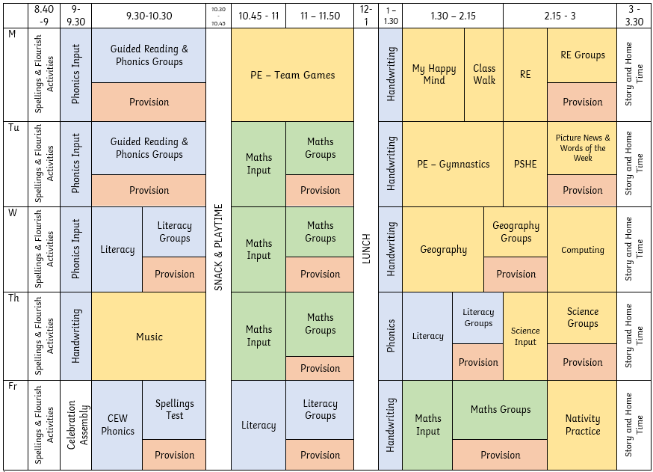

Things I need to remember…
- PE days – Monday & Tuesday
- To bring my book folder in everyday

If you have any questions or concerns, please don’t hesitate to message me on Class Dojo!

