Year 1 Newsletter
Spring Term 1
Welcome back I hope you had a great Christmas and wishing you all a happy new year!
Our plans for this term…
This term we have got lots of exciting things ahead, we are going to be looking at materials in science, coding and data collecting using Purple Mash in computing, in history we are looking famous people who were and are from the UK, in art we are looking at sculptures made from materials and lastly, in RE we are considering how the world began.

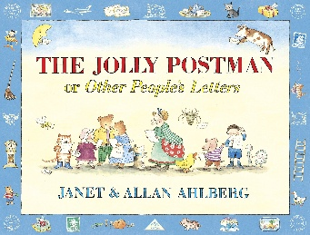
Literacy
In Literacy we will be focusing on writing a letter using the book, The Jolly Postman. We will also be focusing on using conjunctions such as, and, or, but within sentences.

Phonics
In Phonics, we will still retrieve previous graphemes from year R, we will continue looking at new graphemes, using them in our daily writing, practicing segmenting for spellings and using all their knowledge to write more detailed sentences.

Maths
In maths we will be finishing off our learning about grouping and sorting shapes. After we will be looking at place value within 20 and lastly moving onto addition and subtracting to 20.

Reading
We will continue to complete reading checks on Monday and give out new Monster Phonics books. We are asking for book folders to be in school every day. As a school we ask that reading at home is done at least 3 times a week and a family member signs their reading record book.

Continuous Provision & Rainbow Challenges
In year 1, we continue to offer a rich and engaging continuous provision environment that supports all areas of learning. A highlight of our week is the Rainbow Challenge - children are encouraged to complete five activities throughout the week, each linked to a different area of learning and represented by a colour. Once they've collected all five, they receive a prize to celebrate their effort and resilience. It’s a fun and motivating way to encourage independence, exploration, and a love of learning!

Timetable
Below I have attached a rough outline of what we will be doing each day – it looks very confusing with all the colours, I know!
Blue is for writing, reading or phonics. Green is for maths. Yellow is for topic-based lessons and then lastly, red is for provision.

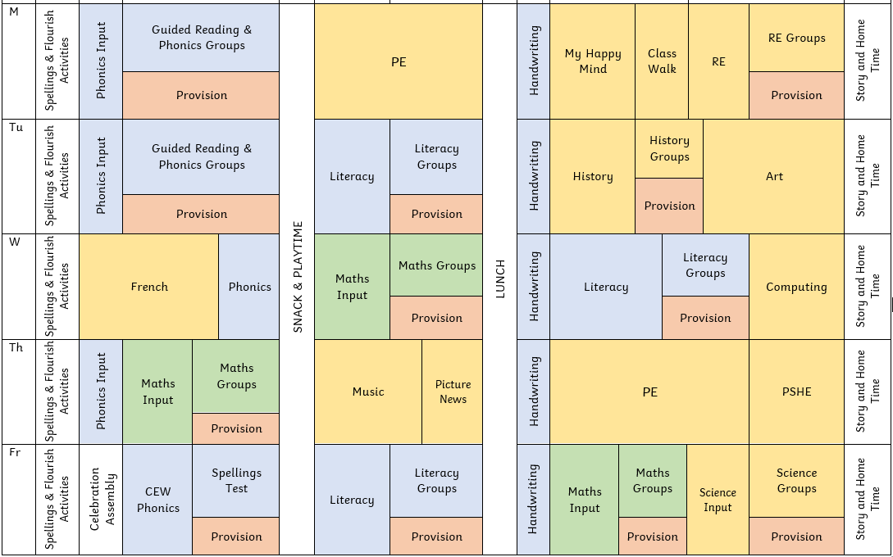

Things I need to remember…
- PE days – Monday & Thursday
- To bring my book folder in everyday

If you have any questions or concerns, please don’t hesitate to message me on Class Dojo!

